15 Sep 2020

EMA/444925/2018

Information Management Division

IRIS guide for applicants   
*(how to create and submit scientific applications, for industry and individual applicants)*

Version 1.10

1. Purpose and context 3

1.1. Purpose of this guide 3

1.2. Preliminary requirement 3

1.3. Supported Browsers 3

2. Common operations for all scientific submission types 3

2.1. Display and sort submissions 3

2.2. Search for submissions 3

2.3. Create a new submission (general procedure for all submission types) 4

2.4. Add contributors to a draft submission 7

2.5. Delete a draft submission 7

2.6. Respond to a notification email from EMA requesting changes 7

2.7. Respond to a List of Questions (LoQ) request 8

2.8. Check the current status of an ongoing Submission in the IRIS Portal 9

2.9. Regulatory Entitlements Affiliation 10

2.10. User’s view for Research Product Identifier (RPI) 11

3. Orphan submissions 11

3.1. Create an application for orphan designation 11

3.2. Request a Pre-Submission Meeting (for OD) 12

3.3. Request an Appeal (of a COMP Opinion) 12

3.4. Submit an Annual Report for an orphan designation 13

3.5. Other post-designation procedures for orphan-designated products 13

3.6. How to check if an Orphan Drug Sponsor (Location of an organisation) has associated Regulatory entitlements 14

4. Scientific Advice 15

4.1. Create an application for an Initial Scientific Advice (Human) 15

4.2. Create an application for other Scientific Advice procedures 16

4.2.1. Initial Scientific Advice – Veterinary 16

4.2.2. Initial Protocol Assistance 16

4.2.3. Initial Qualification Procedure 16

4.2.4. Follow up Scientific Advice – Human 16

4.2.5. Follow up Scientific Advice – Veterinary 16

4.2.6. Follow up Protocol Assistance 17

4.2.7. Follow up Qualification Procedure 17

5. ITF Briefing Meeting Requests 18

6. Appendix 20

6.1. Scientific Advice FAQs 20

1. Purpose and context
   1. Purpose of this guide

This guide has been produced to show applicants how to use the [IRIS](https://iris.ema.europa.eu/) platform to prepare and submit an application for a scientific procedure (e.g. orphan designation application, scientific advice, or ITF briefing meeting request) and related activities, including also Marketing Status reporting.

For Parallel Distribution procedures separate IAM roles are needed, and separate guidance is available in the [IRIS](https://iris.ema.europa.eu/) home page.

* 1. Preliminary requirement

**EMA Account and appropriate role**: for any type of submission in IRIS, you need an EMA account and an appropriate role in IRIS, to login into IRIS. Registration needs to be done only once and will allow you to submit any type of scientific applications now and in the future. For information on how to request an EMA account and an appropriate IRIS role (these are two separate actions), please consult the separate [IRIS guide to registration](https://www.ema.europa.eu/en/documents/regulatory-procedural-guideline/iris-guide-registration_en.pdf) in the [IRIS home page](https://iris.ema.europa.eu/). This guide also contains information on how to request or transfer an **RPI (Research Product Identifier)**.

* 1. Supported Browsers

IRIS can be accessed on any modern Web Browser, including but not limited to Google Chrome (latest version), Internet Explorer 11 and above, Edge (including the new, Chromium-based Edge), Safari 12 and above, Firefox (latest version), Vivaldi, etc.

1. Common operations for all scientific submission types
   1. Display and sort submissions
2. From the IRIS home page, after sign-in, click on any of the options: “Draft Submissions”, “Ongoing Submissions” or “Completed Submissions” present under “Submissions” Tab;
3. If you have an IRIS Industry Manager role, you will see all the submissions that you have created, plus all the submissions in which you have been added as a contributor. If you have a Contributor role, you will see all the Submissions to which you have been added as a Contributor. If you have both roles, you will see all submissions of your own and those for which you have been added as a Contributor. In all cases, you will see submissions for all the Organisations to which you are affiliated (in IAM);
4. Click on any of the column headings that appear in blue font, and the rows listed in the table will be sorted in ascending order (click again for descending order).
   1. Search for submissions
5. You can obtain a restricted subset of your submissions: from the IRIS home page, select first: “Draft Submissions”, “Ongoing Submissions” or “Completed Submissions”;
6. In the search bar, enter any string (combination of letters and/or numbers) that will identify the submission you are looking for and might be contained in the columns that are displayed on screen (e.g. "Submission ID", "Organisation", "Submission Type"); by including an asterisk (*) as first character, the search string will apply to text in any position.
7. Click on the magnifying glass search symbol or press "Enter" on your keyboard to launch the search;
8. A list of the relevant results that match the search criterion you typed in the search bar will be displayed. The list can be sorted as described in the previous section.
9. In “Draft submissions”, a menu of different actions can be elicited by clicking on the down arrow to the right of the relevant submission. You can edit or delete the submission, manage the contributors and managers, and you can change the “submission contact” (the person who will receive by default all the email communications for the procedure). See Figure 1 below.

Figure 1- managing draft submissions

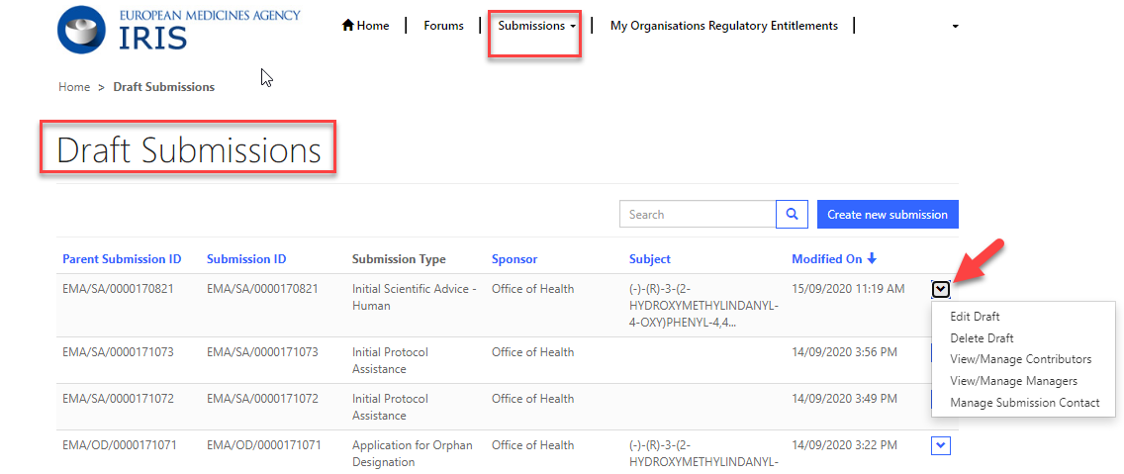

* 1. Create a new submission (general procedure for all submission types)

1. From the IRIS home page, click on “**Draft submissions**” sub-tab present under “Submission” tab;
2. Click “**Create new submission**” [a screen with the heading “Portal – New Submissions” opens showing 4 stages. The first stage “**1. Choose Sponsor Type**” is highlighted in blue];
3. From the drop-down arrow on the box below “**Are you applying as an individual or on behalf of an organisation?**” select the appropriate answer and click “**Next**”;
4. Only if you are applying on behalf of an organisation:
5. Use the magnifying glass search symbol to look up the organisations available for you to select (N.B. only the organisation(s) affiliated to the portal user role that you logged into the portal as will be displayed here);
6. Pick the right organisation and (there may only be one) and click “**Select**”;
7. Use the search symbol to look up the locations available for you to select, pick the right one and click “**Select**”; please note that the Regulatory entitlement (Orphan Designation) will be granted to the address of this location and the relevant organisation.   
     
   **NOTE: it is strongly recommended to use only one location (normally the legal seat of the organisation) for all IRIS submissions, RPIs and regulatory entitlements. This simplifies your management of submissions in IRIS.**
8. “**Choose Submission Type**” is now coloured blue and 3 mandatory fields (marked with a red asterisk “**\***”) appear labelled “**Organisation**” “**Location**” and “**Submission Type**” (the first two only if you are applying on behalf of an organisation). Use the search symbol to look up the submission types available, click on the appropriate submission type and then on “**Select**”.
9. Add at least one Manager in the specific field (when applying on behalf of an organisation, the popup list will only include those people who have been granted an IRIS Industry Manager access role that is affiliated to the specific organisation (Company + Country) you selected in the previous screen. If no-one has done this, the list will be empty). **It is strongly recommended to have at least two Managers (preferably three) for each IRIS submission**: this will allow the applicant continued access to the submission even if one the managers leaves the company or is absent for prolonged periods.
10. Click “**Create and Next**”. A new screen appears with a reference number (e.g. EMA/XX/0000001234) for your draft submission displayed on the upper right-hand side of the “Portal – New Submission” screen (N.B. It is a good idea to take note of the reference number created). There is also now a list of various tabs (steps) including “**Select RPI**” and ending with “**Declaration**”) relating to the submission reference displayed on the left-hand side of your screen. See Figure 2.

Figure 2 - Example of new submission

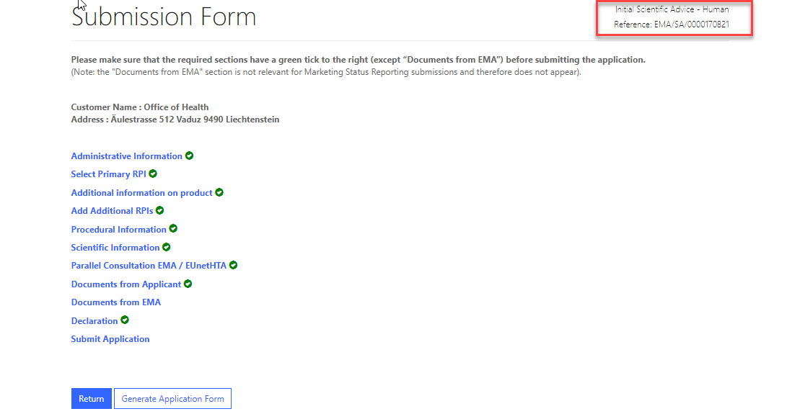

1. Click on “**Select RPI**” to bring up “Research Product Identifier (RPI)” screen:
   1. Click the **magnifying glass** search symbol to bring up a list of RPI names;
   2. In the pop-up window, pick an RPI name from the list and click “**Select**”;
   3. Back in the “Research Product Identifier (RPI)” screen, click “**Save and Return**” and you are returned to the “Submission Form” screen;

If you do not see the RPI for your product in the list:

* An RPI tracks the development of a medicinal product. The RPI remains the same when the name of the substance(s) in the product changes, or when development of the product is transferred to a different product. If you have already submitted an application to EMA for your product, it is very likely that an RPI already exists, and that one should be used.
* The RPI may already exist, but “owned” by another sister company in the same or a different country, a different company or a consultant, or it may be assigned to a different location of your organisation. In such cases, it won’t appear in the selection list, and you need either to request affiliation to the RPI “owner”, or the “owner” should transfer[1] the RPI to your company, depending on which company should be the sponsor of the orphan designation. **It is recommended that all RPIs (and regulatory entitlement) for an organisation are assigned to the same location (normally the legal seat of the organisation).**
* If you are sure that no RPI exists for the medicinal product yet, please request one via IRIS following [the IRIS guide to registration](https://www.ema.europa.eu/en/documents/regulatory-procedural-guideline/iris-guide-registration_en.pdf) section: ‘*8. How to create a ‘Request for a ‘Research Product Identifier’*. This is a separate submission. After receiving communication from EMA that your RPI has been created, you can **go back to your draft submission and** proceed to the steps below.
* If your RPI is intended to cover **multiple products** or a **methodology/ technology** or a **method** or **other** (not a single product), please contact [ITFSecretariat@ema.europa.eu](mailto:ITFSecretariat@ema.europa.eu) or [SA_Submissions@ema.europa.eu](mailto:SA_Submissions@ema.europa.eu) beforehand (depending on your intended procedure type). You will be requested to complete a specific Word form. Upon receipt of the form the secretariat will create an RPI for you. These ‘special’ RPIs cannot be requested via IRIS.

1. Click on “Additional product information/update”:
   1. Make sure that the list of innovation/enabling technologies includes at least one term; if not, choose at least one with the “Add” button;
   2. Click “**Save and return**”.
2. Once the RPI data (and any other mandatory sections) are completed, all the sections (tabs) will turn from grey to blue and will be active (see Figure 2). Fill in each section. Please note that fields with a red asterisk are mandatory. You need to complete each section before you can save it, but it is not mandatory to fill in all the section in one session.
3. Back in the main “**Submission Form**” Screen, click on “**Documents from Applicant**”:
   1. In the next screen that appears, you can directly upload documents and create subfolders in your submission. While there is no maximum number of files or global size, there is a size limit of 50 Mb per file. Please upload individual files for each document, rather than a single Zip file (or similar) for the set of all documents. A Zip file is acceptable only as the container for the literature references.
   2. Click “**Save and Return**” when you have finished uploading documents;
4. At any stage during the procedure above, clicking “Return” on the Submission form page saves the draft submission (which will now appear in your “**Draft Submissions**” list). You can open it again at a later time to edit/add more information;
5. Click on **“Generate Application form”** present at bottom of screen next to **“Return”** button to create a word file for the summary of application filled at that point of time by the applicant. Word file will be shown under section 3.1 point10 **“Documents from Applicant”;**
6. When you are ready to submit your final application, click on “**Declaration and re(submission)**”:
   1. **Click on the tick box** to the left of the declaration statement (that begins with the words: “I confirm…”) to formally declare that you are authorised to submit the application;
   2. Click on the “**Declaration and submission**” button;
   3. If you are unsure or think of any part of the application you want to revise, click “**Review Application**” and this will return you to the draft submission;
   4. If you are sure you want to submit the application, click” Submit”.

Your application has now been submitted and is locked for edit/upload unless EMA opens it up again for you to add or amend any information or documents.

You are then returned to the portal **“Ongoing Submissions”** tab. You can now look up the submission you have just submitted using the **“Ongoing Submission”.** The latest submission will appear on top once validation is completed in background, as submissions are sorted by date and time of last update.

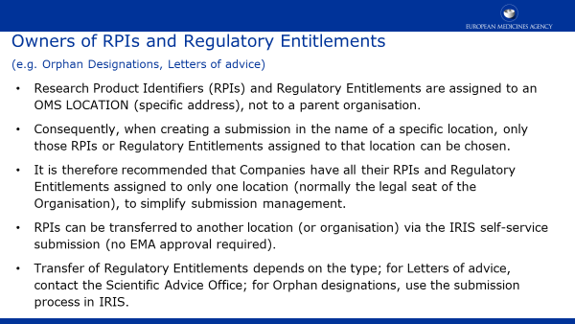

* 1. Add contributors to a draft submission

You can only do this for the draft applications for which you have a **“Manager”** role (not if you are a Contributor).

From the IRIS home page, carry out the following steps (see also Figure 1):

1. Click on "**Draft submissions**" sub-tab present under **“Submission”** tab;
2. Scroll down and find the application you want from the list of your drafts;
3. On the right hand side, click on the drop-down arrow and select “**Manage Contributors**”;
4. Click “**Add**”, then In the pop-up window, click the **magnifying glass search symbol** to bring up a list (and find the name you want to add as a contributor;
5. Click “**Continue to submission form**”;
6. To add more contributors to the same application, repeat the steps above.
   1. Delete a draft submission

You can only do this for the draft applications for which you have a “Manager” role (not if you are a Contributor). Note: you cannot delete a “completed submission”; an “ongoing submission” can be withdrawn, using a similar procedure.

1. Click on "**Draft submissions**" sub-tab present under **“Submission”** tab;
2. Find the application you want from the list of your drafts;
3. On the right hand side, click on the drop-down arrow and select “**Delete Draft**” and a confirmation message will open up in a new window (see Figure 1);
4. Click on the "**Delete**" button to confirm that you want to delete your draft. Note: you cannot undo this afterwards, and the draft submission is permanently deleted from IRIS and cannot be restored.
   1. Respond to a notification email from EMA requesting changes

On receipt of a notification email from EMA stating for example that “Validation Supplementary Information (VSI)” relating to one of your Ongoing Submissions is required, or other changes/updates to the submission data, log into the IRIS portal and carry out the following steps:

1. From the IRIS home page, click on “**Ongoing submissions**” sub-tab present under **“Submission”** tab;
2. Locate the submission mentioned in the e-mail by using the sort or search features described in this Guide, or by just scrolling down the list until you find it;
3. At the end of the row in the list where your submission appears, click on the drop-down arrow and select “**View/edit**”;
4. In the “**Submission Form**” page that appears click on the sections that you need to update as stated in the notification you received from EMA (e.g.: General Information, Scientific information, etc.);
5. The selected sections will open in edit mode - make the requested modifications and click on “**Save and Return**” - all modifications will have been saved and you will return to the “**Submission Form**” page;
6. If you need to upload updated or new documents, click on “**Documents from Applicant**”. Click on **“Save and Return”** when you are done;
7. **Click on the tick box** to the left of the declaration statement (that begins with the words: “I confirm…”) to formally declare that you are authorised to submit this request;
8. Click on the “**Declaration and submission**” button;
9. If you are sure you want to submit the application, click” **Submit**”, then “Ok” and then “**Submit**”.
   1. Respond to a List of Questions (LoQ) request

On receipt of a notification email from EMA regarding a “List of Questions (LoQ)” relating to one of your Ongoing Submissions, after validation and start of procedure, you can upload revised/new documents, but you cannot modify the submission data in the portal. Log into the IRIS portal and carry out the following steps:

1. From the IRIS home page, click on “**Ongoing submissions**” sub-tab present under **“Submission”** tab;
2. Locate the submission mentioned in the e-mail;
3. At the end of the row in the list where your submission appears, click on the drop-down arrow and select “**View/edit**” –
4. Click on “**Documents from Applicant**”; click on **“Save and Return”** when you are done;
5. **Click on the tick box** to the left of the declaration statement (that begins with the words: “I confirm…”) to formally declare that you are authorised to submit this request;
6. Click on the “**Declaration and submission**” button;
7. If you are sure you want to submit the application, click “**Submit**”, then “OK” and then “**Submit**”.

Your updated application has now been submitted and will appear in your “Ongoing Submissions” list and you will receive an e-mail notification to confirm that you have re-submitted the application as requested by EMA.

* 1. Check the current status of an ongoing Submission in the IRIS Portal

The possible status for the Applicant’s submission (Figure 3-Submisson Status) and the EMA procedure (case)(Figure 4- Case Status) are shown in the tables:

Figure 3-Submisson Status

|  |  |
| --- | --- |
| **Submission Status** | **Notes** |
| Draft | The application is in draft status and can be deleted or submitted (when finalized) |
| In Progress | Application submitted; case ongoing at EMA |
| Withdrawal Requested | The applicant has requested a withdrawal, which is being assessed at EMA. |
| Completed-Positive | Case closed, positive outcome |
| Completed-Negative | Case closed, negative outcome |
| Completed-Withdrawn | Case closed as withdrawn, at the applicant’s request. |

Figure 4- Case Status

|  |  |
| --- | --- |
| **Case Status** | **Notes** |
| Submitted | Application received by EMA |
| In Progress | Under validation by EMA |
| Start of Procedure | Evaluation team assigned |
| Under Evaluation by EMA |  |
| For list of Questions/Opinion | At the next Committee meeting, either an Opinion or a List of Questions will be adopted |
| For Opinion | At the next Committee meeting, an Opinion will be adopted |
| Opinion Adopted | The EMA Committee has adopted an Opinion |
| Under Appeal | Appeal of the opinion ongoing |
| Pending EC Decision | The Opinion has been submitted to the European Commission |
| Pending Resolution | The Case (procedure) is about to be closed |
| Withdrawal Requested | The withdrawal requested by the applicant is being evaluated |
| Positive | A positive decision has been adopted by the EU (or EMA). The case is closed. |
| Negative | A negative decision has been adopted by the EU (or EMA). The case closed. |
| Closed | The case has been closed by EMA before an Opinion was adopted. |
| Completed | The case has been completed, but no positive or negative Opinion has been adopted (e.g. Scientific Advice completion) |
| Withdrawn | The case has been closed as withdrawn, at the request of the applicant |
| Validation unsuccessful | The submission could not be validated by EMA, and the case is thus closed. It is possible to prepare a new submission. |
| Waiting for Details | The applicant is expected to provide additional details. |

* 1. Regulatory Entitlements Affiliation

1. **My Affiliated Entitlements**

The tab enables users to see a list of all regulatory entitlements related to the organisation(s) the user is affiliated to. It is possible to filter the regulatory entitlements by entitlement number, entitlement type, sponsor, product name, EU number, and date of decision (Figure 5)

Figure 5: My Organisations Regulatory Entitlements

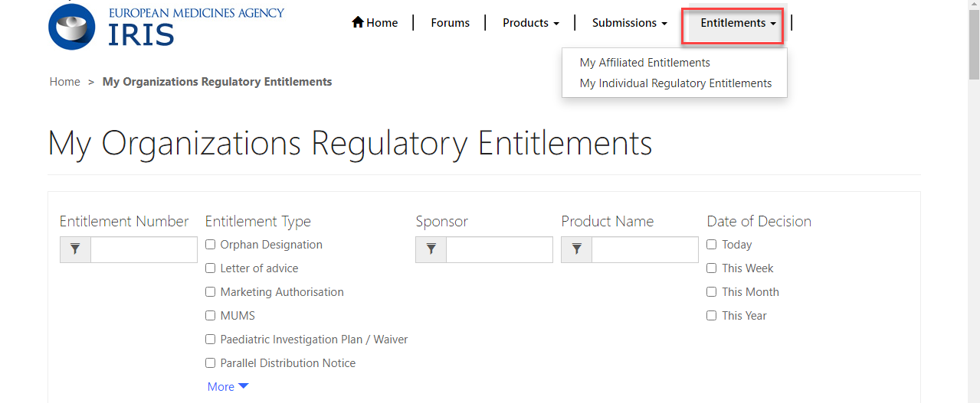

1. **My Individual Regulatory Entitlements**

The tab enables users to see the list of all regulatory entitlements that were granted as an outcome of submissions created by the person logged into the portal. It is possible to filter the regulatory entitlements by entitlement number, entitlement type, product name and date of decision

Figure 6:My Individual Regulatory Entitlements

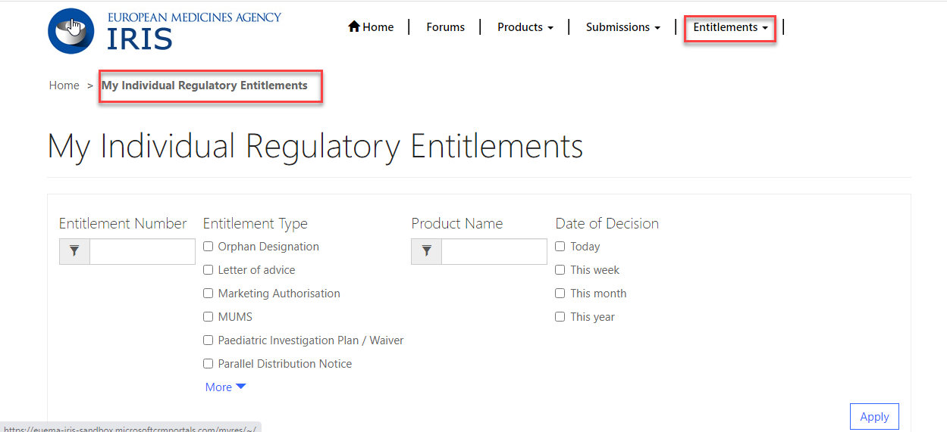

* 1. User’s view for Research Product Identifier (RPI)

IRIS Industry user can see all RPIs (Research Product Identifier) for which they are the sponsor, either individually or via an affiliation to one or more companies. Two views will be shown to user logged into portal as in Figure 7

1. “**My Direct RPIs**", which displays all active RPIs for which the user is direct sponsor.
2. “**My Organisations RPI**” shows active RPIs for all organization locations the user is affiliated to (in any of the locations).

Figure 7: Product-View of RPI's

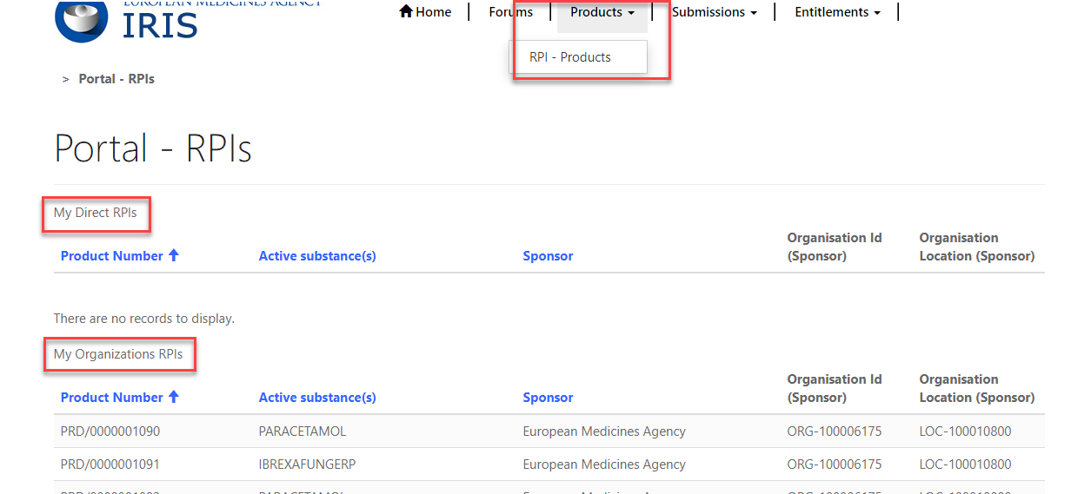

1. Orphan submissions

For general information on orphan designation and allied procedures, please consult the [Orphan Designation](https://www.ema.europa.eu/en/human-regulatory/research-development/orphan-designation-research-developmenthttps:/www.ema.europa.eu/en/human-regulatory/research-development/orphan-designation-research-development) page of the EMA website. For specific information on how to prepare a specific Orphan submission, including how to prepare the Scientific Document, please see the specific sections on the [Orphan Designation](https://www.ema.europa.eu/en/human-regulatory/research-development/orphan-designation-research-developmenthttps:/www.ema.europa.eu/en/human-regulatory/research-development/orphan-designation-research-development) page.

* 1. Create an application for orphan designation

In addition to the steps in the general procedure described in Create a new submission (general procedure for all submission types), please note the specific issues for orphan designation below:

1. The reference number will have “OD” in it (e.g. EMA/OD/0000001234) for your draft submission displayed on the upper right-hand side of the “Portal – New Submission” screen.

Figure 8 - Application for orphan designation, main screen

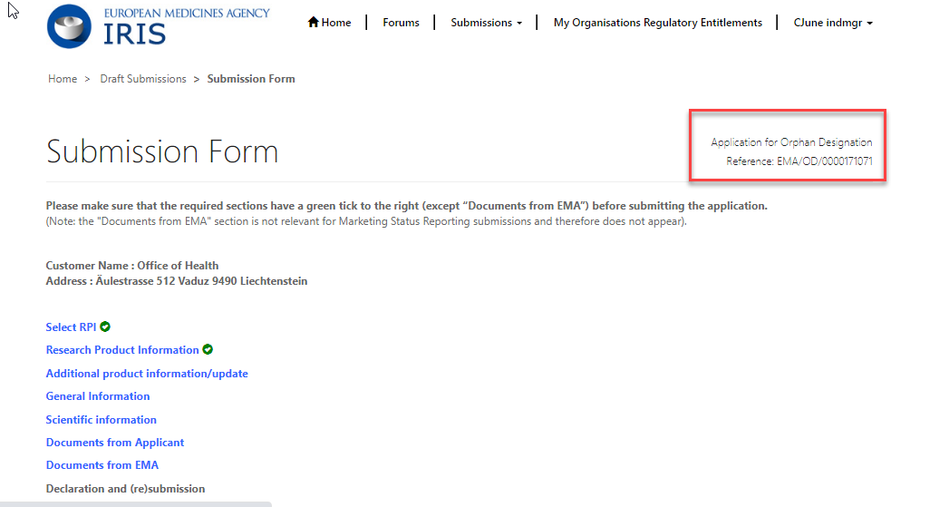

1. The sections (tabs) of the submission are: “**General Information**” and “**Scientific Information**”. Complete (at least) the mandatory fields marked with a red asterisk “**\***” and click “**Save and Return**” (N.B. in the prevalence box, enter the prevalence per 10,000 persons in the EU population, as a single number (normally, from 0 to 5.0) and NOT in the form of a ratio). See Figure 3.
   1. Request a Pre-Submission Meeting (for OD)
2. **IMPORTANT**: before creating a request for a **pre-submission meeting**, please create the draft submission for the orphan designations as described above. This must be left as a draft, without submitting it for the moment. Any documents should be uploaded within the draft submission for orphan designations, not in the pre-submission meeting request. The number of the draft request for orphan designation should be referenced in the pre-submission meeting request;
3. Follow steps 1 to 8 from 3.1. above, selecting “**Request for Pre-Submission Meeting**” as procedure type;
4. Click “**Continue to submission form**” and a number (e.g. EMA/OD/0000001234) for your draft submission is displayed on the upper right-hand side of the “Portal – New Submission” screen (N.B. It is a good idea to take note of the reference number created);
5. Back in the Submission Form screen, click on “**Submission Details**”, enter the information that you want the EMA Orphan Medicines team to know and click “**Save and Return**”;
6. Follow steps 15 and 16 from 3.1. above;
7. Your request for a Pre-Submission Meeting has now been submitted and will appear in your “**Ongoing Submissions**” list.
   1. Request an Appeal (of a COMP Opinion)

In addition to the steps in the general procedure as described in Create a new submission (general procedure for all submission types), note the following:

1. As submission type, click on “**Appeal**” and then click “**Select**”;
2. Click “**Create and Next**” – you will see the message “processing…” for a short while;
3. Click “**Continue to submission form**”;
4. Click on “**Start Appeal**” and the “View Start Appeal Form” screen appears;
   1. Click on the magnifying glass to select the procedure to be appealed – only cases which have been submitted and are currently in ongoing status are displayed;
   2. Click on one of the procedures listed then click Select” and “Submit”;
5. From the “**Submission Form**” screen, click on the “**Ground of appeal**” Section; fill in the relevant information in the mandatory “Applicant's grounds for appeal **\***” box and click “**Save and Return**”;
   1. Submit an Annual Report for an orphan designation

The process for submitting Annual Reports has now been simplified. Applicants are not requested to compile and submit the previous PDF form, which has been removed from the website. It is now only necessary to complete the information in a few specific data fields in IRIS. Uploading additional supporting documents is still possible but not mandatory.

In addition to the steps in the general procedure as described in Create a new submission (general procedure for all submission types), note the following additional points:

1. As submission type, click on “**Annual Report**” and then click “**Select**”;
2. Click “**Create and Next**” and then click “**Continue to submission form**”;
3. Click on “**Regulatory Entitlement**” (a generic term for a right granted to a sponsor such as an orphan designation or a transfer of orphan designation);
   1. In the “Regulatory Entitlement” window, **click on the magnifying glass symbol** to search through the existing orphan designations for your organisation;
   2. Select the orphan designation for which you are submitting the Annual Report and click “**Save and Return**”. If you cannot find your orphan designation, please contact the Orphan medicines office;
4. Click on “**Scientific content**” and complete the information in the data fields, amending the prefilled fields where appropriate. All fields with an asterisk are mandatory. Click on “**Save and Return**”;
5. Back in the Submission Form screen, click on “**Submission Notes**”, enter any additional free-text information that you want the EMA Orphan Medicines team to know and click “**Save and Return**”.
   1. Other post-designation procedures for orphan-designated products

All other post-designation procedures for existing orphan designations should be submitted via IRIS, choosing the appropriate procedure type. These include:

* Submission of a report for the Maintenance of the Designation Criteria at Marketing authorisation (or extensions)
* Submission of a report for a Review of the Designation criteria after 5 years
* Request for an Amendment of an existing Orphan designation (to change the condition)
* Request to transfer an Orphan Designation
* Request of removal of an Orphan designation from the EC Orphan register
* Change of name and/or address of the Sponsor of an orphan designation.

The procedures are very similar to the general procedure as described in Create a new submission (general procedure for all submission types), and are not listed for brevity. For general information on these submission types, see the [Activities after orphan designation](https://www.ema.europa.eu/en/human-regulatory/research-development/orphan-designation/activities-after-orphan-designation) webpage in the main EMA website.

* 1. How to check if an Orphan Drug Sponsor (Location of an organisation) has associated Regulatory entitlements

Go to Link <https://ec.europa.eu/health/documents/community-register/html/reg_od_act.htm?sort=a> and search for EU product e.g. EU/3/19/2181.

Click on the EU number from the search results. For field "Sponsor" -Organisation name and location will be mentioned. This location has Regulatory entitlements and the same can be selected in IRIS while drafting a form.

1. Scientific Advice

For general information on Scientific Advice, please consult the [Scientific advice and protocol assistance](https://www.ema.europa.eu/en/human-regulatory/research-development/scientific-advice-protocol-assistance) section of the EMA website. For specific information on how to prepare a Scientific Advice submission, including the Scientific Document (Briefing Document), please see the [How to submit a scientific advice or protocol assistance request](https://www.ema.europa.eu/en/human-regulatory/research-development/scientific-advice-protocol-assistance/how-submit-scientific-advice-protocol-assistance-request) section on the EMA website.

* 1. Create an application for an Initial Scientific Advice (Human)

In addition to the steps in the general procedure as described in section 2.3 Create a new submission (general procedure for all submission types), select **“Initial Scientific Advice-Human”** as the type of submission. Note the following additional points:

The reference number will contain SA (e.g. EMA/SA/0000001234) for your draft submission displayed on the upper right-hand side of the “Portal – New Submission” screen.

There is a list of eleven steps (tabs) starting with “Administrative Information” and ending with “Declaration”) relating to the OD Application displayed on the left-hand side of your screen; the two sections “Administrative Information” and “Select Primary RPI” must be completed, before the other sections (tabs) become available (they turn from grey to blue).

You can optionally select additional (secondary) RPIs to link to your procedure by clicking on “Add Additional RPIs” (Figure 4). Note that only RPIs “owned” by the same applicant can be added.

Some sections/tabs may not be applicable, e.g. “Parallel Consultation EMA/EUnetHTA”; however, at least the mandatory field(s) marked with a red asterisk “*” should be completed.

Figure 9 - How to include additional RPIs

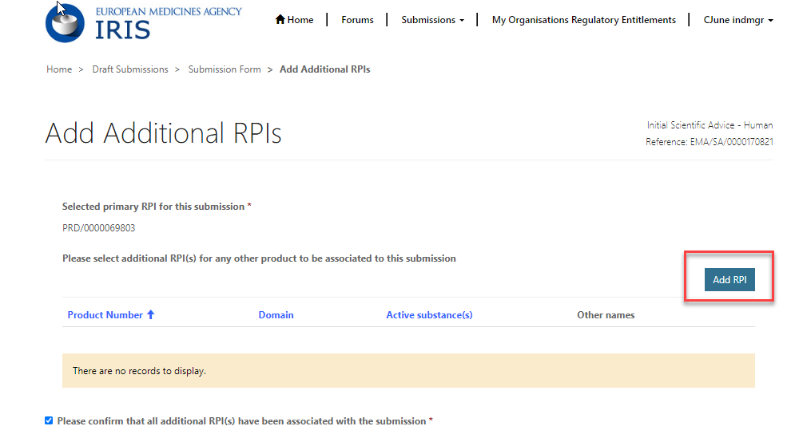

* 1. Create an application for other Scientific Advice procedures
     1. Initial Scientific Advice – Veterinary

Follow the steps in the general procedure as described in section 2.3 Create a new submission (general procedure for all submission types), selecting **“Initial Scientific Advice-Veterinary”** as type of submission.

* + 1. Initial Protocol Assistance

Protocol Assistance is Scientific Advice for designated orphan medicinal products. In addition to questions on quality, safety and clinical aspects, questions on significant benefit may also be discussed.

In addition to the steps in the general procedure as described in section 2.3 Create a new submission (general procedure for all submission types), note the following additional points:

* The applicant must be the same as the Orphan Designation Sponsor.
* While drafting this type of application, applicant cannot proceed further than **“Orphan Designation”** until an existing orphan designation (or at least a positive opinion date), for a product belonging to the same customer, has been selected first and associated to the submission. It is possible to submit the application after a COMP Opinion has been adopted, but before the formal Decision by the European Commission, by choosing the ongoing procedure instead of an Orphan Designation; however, the Decision must be adopted before the start date of the Protocol Assistance procedure.
* Please note that several fields will be prepopulated from the associated orphan case and cannot be changed. These include the RPI and the medical condition (which must be the same as the orphan condition in the designation, by law).
  + 1. Initial Qualification Procedure

In addition to the steps in the general procedure as described in section 2.3 Create a new submission (general procedure for all submission types), note the following additional points:

* Select **“Initial Qualification Procedure”** as Submission Type.
  + 1. Follow up Scientific Advice – Human

In addition to the steps in the general procedure as described in section 2.3 Create a new submission (general procedure for all submission types), note the following additional points:

* Select **“Follow up Scientific Advice-Human”** as Submission Type;
* You will be able to proceed only by selecting a previously completed Scientific Advice procedure (chosen from the popup list, showing procedure number and condition for all scientific advices, from any applicant). This is done in section **“Select Previous Scientific Advice”** for selection.
* An RPI is mandatory; if the RPI was present in the previous Scientific Advice, it will be added automatically, otherwise it is necessary to choose an existing RPI (assigned to the same location).
* Please note that several fields will be prepopulated from the previously completed initial scientific advice case and cannot be changed. These include the RPI, the medical condition, and the areas of advice. Only previously discussed areas of advice (or a subset) can be included in a follow-up procedure.
  + 1. Follow up Scientific Advice – Veterinary

In addition to the steps in the general procedure as described in section 2.3 Create a new submission (general procedure for all submission types), note the following additional points:

* Select **“Follow up Scientific Advice-Veterinary”** as Submission Type;
* You will be able to proceed only after selecting a previously completed Scientific Advice – Veterinary procedure;
* An RPI is mandatory; if the RPI was present in the previous Scientific Advice, it will be added automatically, otherwise it is necessary to choose an existing RPI (assigned to the same location).
  + 1. Follow up Protocol Assistance

In addition to the steps in the general procedure as described in section 2.3 Create a new submission (general procedure for all submission types), note the following additional points:

* Select **“Follow up Protocol Assistance”** as Submission Type. Please note that it is possible to select this procedure type even if the previous submission was made for Scientific Advice, rather than protocol Assistance;
* You will be able to proceed only after selecting a previously completed Scientific Advice or Protocol Assistance procedure. These appear in the section **“Select Previous Scientific Advise”** for selection.
* While drafting this type of application, applicant cannot proceed further than **“Orphan Designation”** until an existing orphan designation (or at least a positive opinion date), for a product belonging to the same customer, has been selected first and associated to the submission. It is possible to submit the application after a COMP Opinion has been adopted, but before the formal Decision by the European Commission, by choosing the ongoing procedure instead of an Orphan Designation; however, the Decision must be adopted before the start date of the Protocol Assistance procedure.
* Please note that several fields will be prepopulated from the associated orphan case and cannot be changed. These include the RPI and the medical condition (which must be the same as the orphan condition in the designation, by law).
  + 1. Follow up Qualification Procedure

In addition to the steps in the general procedure as described in section 2.3 Create a new submission (general procedure for all submission types), note the following additional points:

* Select **“Follow up Qualification Procedure”** as Submission Type;
* You will be able to proceed only after selecting a previously completed Qualification procedure. These appear in section **“Select Previous Scientific Advice”** for selection.

1. ITF Briefing Meeting Requests

***First stage (Creation of draft):***

1. In the [IRIS portal](https://iris.ema.europa.eu/), **Sign-in** using your credentials from the EMA account registration. You will see your profile, which you will be able to amend and save.
2. Click on “**Draft submissions**”, then on “**Create new submission**”.
3. From the drop-down arrow in the box “**Are you applying as an individual or on behalf of an organisation?**” select either and click “**Next**”; if applying on behalf of an organisation, you will need to select which organisation, among those you are affiliated to, and subsequently the location (address). The organisation must be already registered in the EMA Organisation Management System (OMS). Refer to the [IRIS guide to registration](https://www.ema.europa.eu/en/documents/regulatory-procedural-guideline/iris-guide-registration_en.pdf) section ‘*4. Organisation registration in OMS (SPOR).’*
4. In **‘Submission type’** window, use the search symbol to look up the submission types available, click on “**ITF Briefing Meeting Request**” and click on “**Select**”. Then choose **‘Manager’** from drop down list and add yourself. If applying on behalf of an organisation, you can also add other managers, among those also affiliated to that organisation with the role of Manager. It is recommended to have at least two managers.
5. Click on “**Create and Next”/ “Submit”.** A new screen appears, where first step is to choose a Research Product Identifier (RPI).

***Second stage (Research Product Identifier):***

1. An RPI identifies a unitary research and development process, for a single product or a technology, methodology, multiple products. Click on “**Select RPI**”, then on the **magnifying glass** search symbol to bring up a list of RPIs numbers already assigned to you (or your organisation) and select one to proceed, then click on “**Save and return**”.

**If you do not see the appropriate RPI in the list**:

* 1. Make sure you read the instruction in the RPI selection page. The RPI may already exist, but “owned” by another sister company in the same or a different country, a different company or a consultant. In such cases, it won’t appear in the selection list, and you need either to request affiliation to the RPI “owner”, or the “owner” should transfer the RPI to your company, depending on which company should be the holder of the Regulatory Entitlement(e.g. Orphan designation, Marketing Authorisation, etc).
  2. Fora new **single medicinal product**, please request one RPI via IRIS following [the IRIS guide to registration](https://www.ema.europa.eu/en/documents/regulatory-procedural-guideline/iris-guide-registration_en.pdf) section: ‘*8. How to create a ‘Request for a ‘Research Product Identifier’*. This is a separate submission. After receiving communication from EMA that your RPI has been created, you can **go back to your draft submission and** proceed to the steps below.
  3. If your RPI is intended to cover **multiple products/ methodology/ technology/ method or other topic**, please contact [ITFSecretariat@ema.europa.eu](mailto:ITFSecretariat@ema.europa.eu) beforehand. You will be provided and requested to complete the ‘*ITF RPI request form’*. Upon receipt of the form the secretariat will create an RPI for you. These ‘special’ RPIs cannot be requested via IRIS.

***Third stage (completion of the submission):***

1. Open and complete all sections of the submission form, from “**Submission details**” until ‘**Declaration’** and click “**Save and Return**”. ***NOTE:*** Mandatory fields marked with a red asterisk “**\***” must be completed. Please input “N/A” if the field is not relevant. You will see green ticks against completed sections.
2. Please ensure you carefully review the input and tick the agreement of the **‘Declaration’** and click on ‘**Submit Application**’. ***NOTE:*** you may ‘**Generate your Application Form’** before submitting it by clicking on this option in this section; this creates a Word file with a summary of your application in the “Documents from Applicant” section, which you can download.
3. Choose your SME status if applicable, in ‘**Please indicate if you have SME status at submission’** section
4. Click on ‘**Submit your Application’**

NOTES:

The section “Documents from applicant” is available to upload any supporting documents but is not mandatory. The documents can be sent to the ITF Secretariat via email.

The section “Documents from EMA” is where you can find any documents provided by EMA to you, including the minutes from the meeting. The ITF Secretariat will email the documents to you.

If you wish to complete your application at the later stage, you may do it so by clicking on ‘Save and return’ under section and come back to the submission later. Your draft submission will be available in ‘Draft Submissions’. You may edit it by clicking on the downward-facing arrow and selecting ‘Edit’.

1. Appendix
   1. Scientific Advice FAQs

Frequently asked questions related to Scientific Advice can be found in “Forums” tab in **[IRIS](https://iris.ema.europa.eu/forums/whats-new/f7f892e9-0fe6-ea11-bf21-0003ff5fd63e)** website.

1. Currently done via an EMA ServiceDesk request. An IRIS procedure is being developed to facilitate and accelerate the transfers.