**Please find the below list of sections which are present in generated application form but not available to be filled in IRIS:**

**Screenshot 1:**

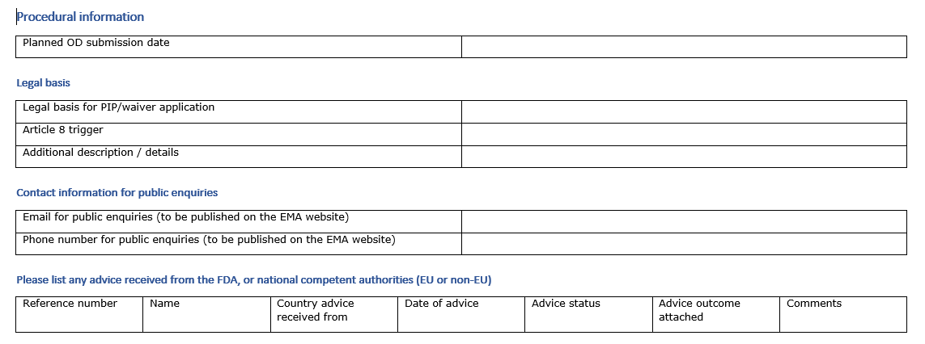

**Screenshot 2:**

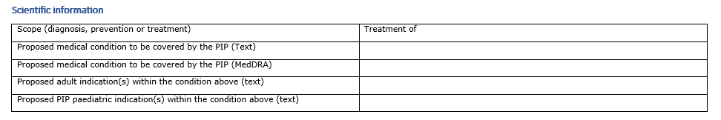

**Screenshot 3:**

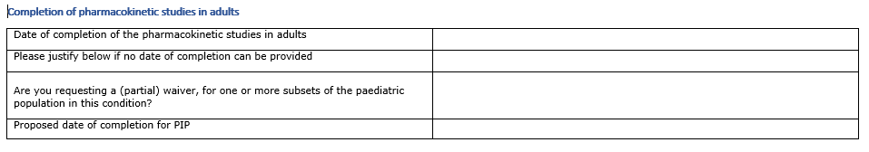

**Screenshot 4:**

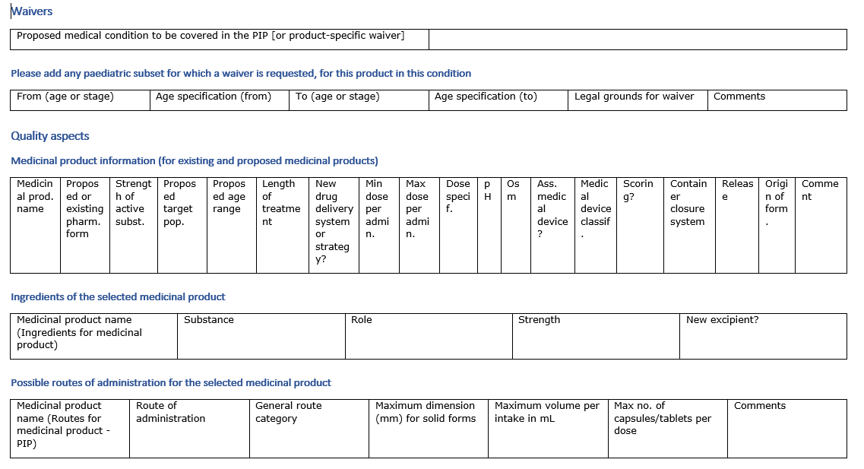

**Please find the below list of sections which are available nnline in IRIS portal but not captured in downloaded eAF:**

**Screenshot 5:**

